**EXERCISE1:SETTING UP JUNIT**

package com.example;

public class Main {

public static void main(String[] args) {

System.out.println("Hello world!");

}

}

package com.example;

import org.junit.Test;

import static org.junit.Assert.*;

public class MyFirstTest {

@Test

public void testAddition() {

int result = 2 + 3;

assertEquals(5, result);

}

}

**POM.XML**

<?xml version="1.0" encoding="UTF-8"?>

<project xmlns="http://maven.apache.org/POM/4.0.0"

xmlns:xsi="http://www.w3.org/2001/XMLSchema-instance"

xsi:schemaLocation="http://maven.apache.org/POM/4.0.0 http://maven.apache.org/xsd/maven-4.0.0.xsd">

<modelVersion>4.0.0</modelVersion>

<groupId>com.example</groupId>

<artifactId>junitdemo</artifactId>

<version>1.0-SNAPSHOT</version>

<properties>

<maven.compiler.source>17</maven.compiler.source>

<maven.compiler.target>17</maven.compiler.target>

</properties>

<dependencies>

<dependency>

<groupId>junit</groupId>

<artifactId>junit</artifactId>

<version>4.13.2</version>

<scope>test</scope>

</dependency>

</dependencies>

</project>

**OUTPUT:**

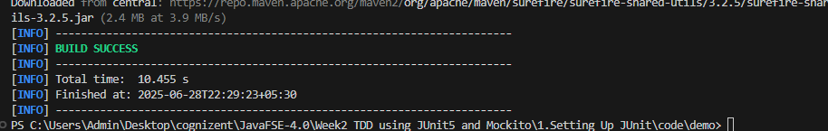

**EXERCISE2:ASSERTIONS IN JUNIT**

package com.example;

public class App {

public static void main(String[] args) {

System.out.println("Hello from App");

}

}

package com.example;

import org.junit.jupiter.api.Test;

import static org.junit.jupiter.api.Assertions.*;

public class AssertionsTest {

@Test

public void testAssertions() {

assertEquals(5, 2 + 3);

assertTrue(5 > 3);

assertFalse(5 < 3);

assertNull(null);

assertNotNull(new Object());

}

}

**POM.XML**

<project xmlns="http://maven.apache.org/POM/4.0.0"

xmlns:xsi="http://www.w3.org/2001/XMLSchema-instance"

xsi:schemaLocation="http://maven.apache.org/POM/4.0.0

http://maven.apache.org/xsd/maven-4.0.0.xsd">

<modelVersion>4.0.0</modelVersion>

<groupId>com.example</groupId>

<artifactId>assertions-demo</artifactId>

<version>1.0-SNAPSHOT</version>

<properties>

<maven.compiler.source>17</maven.compiler.source>

<maven.compiler.target>17</maven.compiler.target>

</properties>

<dependencies>

<dependency>

<groupId>org.junit.jupiter</groupId>

<artifactId>junit-jupiter</artifactId>

<version>5.10.2</version>

<scope>test</scope>

</dependency>

</dependencies>

<build>

<plugins>

<plugin>

<groupId>org.apache.maven.plugins</groupId>

<artifactId>maven-surefire-plugin</artifactId>

<version>3.2.5</version>

</plugin>

</plugins>

</build>

</project>

**OUTPUT:**

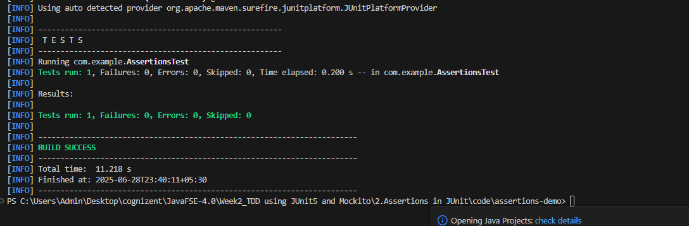

**EXERCISE3:ARRANGE-ACT-ASSERT(AAA)PATTERNS,TEST FIXTURES,SETUP AND TEARDOWN METHODS IN JUNIT**

package com.example;

public class Calculator {

public int add(int a, int b) {

return a + b;

}

public int subtract(int a, int b) {

return a - b;

}

}

package com.example;

import org.junit.jupiter.api.*;

import static org.junit.jupiter.api.Assertions.*;

public class CalculatorTest {

private Calculator calculator;

@BeforeEach

public void setUp() {

// Arrange: Initialize resources

calculator = new Calculator();

System.out.println("Setup before test");

}

@AfterEach

public void tearDown() {

// Cleanup after test

System.out.println("Teardown after test");

}

@Test

public void testAddition() {

// Act

int result = calculator.add(2, 3);

// Assert

assertEquals(5, result);

}

@Test

public void testSubtraction() {

// Act

int result = calculator.subtract(5, 3);

// Assert

assertEquals(2, result);

}

}

**POM.XML**

<project xmlns="http://maven.apache.org/POM/4.0.0"

xmlns:xsi="http://www.w3.org/2001/XMLSchema-instance"

xsi:schemaLocation="http://maven.apache.org/POM/4.0.0

http://maven.apache.org/xsd/maven-4.0.0.xsd">

<modelVersion>4.0.0</modelVersion>

<groupId>com.example</groupId>

<artifactId>aaa-demo</artifactId>

<version>1.0-SNAPSHOT</version>

<properties>

<maven.compiler.source>17</maven.compiler.source>

<maven.compiler.target>17</maven.compiler.target>

</properties>

<dependencies>

<dependency>

<groupId>org.junit.jupiter</groupId>

<artifactId>junit-jupiter</artifactId>

<version>5.10.2</version>

<scope>test</scope>

</dependency>

</dependencies>

<build>

<plugins>

<plugin>

<groupId>org.apache.maven.plugins</groupId>

<artifactId>maven-surefire-plugin</artifactId>

<version>3.2.5</version>

</plugin>

</plugins>

</build>

</project>

**OUTPUT:**

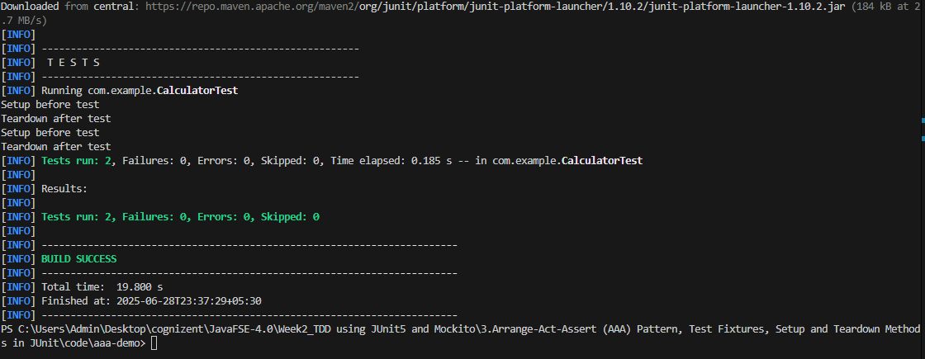

**EXERCISE4:MOCKING AND STUBBING**

package com.example;

public interface ExternalApi {

String getData();

}

package com.example;

public class MyService {

private final ExternalApi api;

public MyService(ExternalApi api) {

this.api = api;

}

public String fetchData() {

return api.getData();

}

}

package com.example;

import static org.mockito.Mockito.*;

import org.junit.jupiter.api.Test;

import org.mockito.Mockito;

import static org.junit.jupiter.api.Assertions.*;

public class MyServiceTest {

@Test

public void testExternalApi() {

ExternalApi mockApi = Mockito.mock(ExternalApi.class);

when(mockApi.getData()).thenReturn("Mock Data");

MyService service = new MyService(mockApi);

String result = service.fetchData();

assertEquals("Mock Data", result);

}

}

**POM.XML**

<project xmlns="http://maven.apache.org/POM/4.0.0"

xmlns:xsi="http://www.w3.org/2001/XMLSchema-instance"

xsi:schemaLocation="http://maven.apache.org/POM/4.0.0

http://maven.apache.org/xsd/maven-4.0.0.xsd">

<modelVersion>4.0.0</modelVersion>

<groupId>com.example</groupId>

<artifactId>mockito-demo</artifactId>

<version>1.0-SNAPSHOT</version>

<properties>

<maven.compiler.source>17</maven.compiler.source>

<maven.compiler.target>17</maven.compiler.target>

</properties>

<dependencies>

<!-- JUnit 5 -->

<dependency>

<groupId>org.junit.jupiter</groupId>

<artifactId>junit-jupiter</artifactId>

<version>5.10.2</version>

<scope>test</scope>

</dependency>

<!-- Mockito -->

<dependency>

<groupId>org.mockito</groupId>

<artifactId>mockito-core</artifactId>

<version>5.12.0</version>

<scope>test</scope>

</dependency>

</dependencies>

<build>

<plugins>

<plugin>

<groupId>org.apache.maven.plugins</groupId>

<artifactId>maven-surefire-plugin</artifactId>

<version>3.2.5</version>

</plugin>

</plugins>

</build>

</project>

**OUTPUT:**

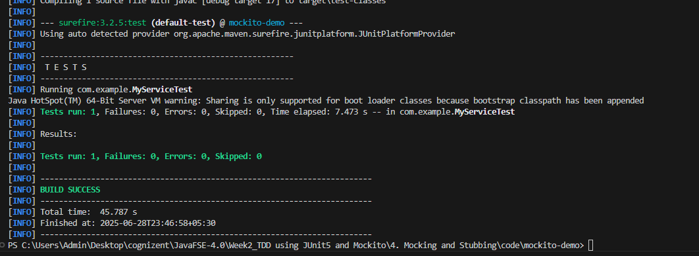

**EXERCISE5:VERIFYING INTERACTIONS**

package com.example;

public interface ExternalApi {

String getData();

}

package com.example;

public class MyService {

private final ExternalApi api;

public MyService(ExternalApi api) {

this.api = api;

}

public String fetchData() {

return api.getData();

}

}

package com.example;

import static org.mockito.Mockito.*;

import org.junit.jupiter.api.Test;

import org.mockito.Mockito;

public class MyServiceTest {

@Test

public void testVerifyInteraction() {

// Arrange

ExternalApi mockApi = Mockito.mock(ExternalApi.class);

MyService service = new MyService(mockApi);

// Act

service.fetchData();

// Assert (verify that getData was called)

verify(mockApi).getData();

}

}

<project xmlns="http://maven.apache.org/POM/4.0.0"

xmlns:xsi="http://www.w3.org/2001/XMLSchema-instance"

xsi:schemaLocation="http://maven.apache.org/POM/4.0.0

http://maven.apache.org/xsd/maven-4.0.0.xsd">

<modelVersion>4.0.0</modelVersion>

<groupId>com.example</groupId>

<artifactId>mockito-verify-demo</artifactId>

<version>1.0-SNAPSHOT</version>

<properties>

<maven.compiler.source>17</maven.compiler.source>

<maven.compiler.target>17</maven.compiler.target>

</properties>

<dependencies>

<!-- JUnit 5 -->

<dependency>

<groupId>org.junit.jupiter</groupId>

<artifactId>junit-jupiter</artifactId>

<version>5.10.2</version>

<scope>test</scope>

</dependency>

<!-- Mockito -->

<dependency>

<groupId>org.mockito</groupId>

<artifactId>mockito-core</artifactId>

<version>5.12.0</version>

<scope>test</scope>

</dependency>

</dependencies>

<build>

<plugins>

<plugin>

<groupId>org.apache.maven.plugins</groupId>

<artifactId>maven-surefire-plugin</artifactId>

<version>3.2.5</version>

</plugin>

</plugins>

</build>

</project>

OUTPUT:

